INVESTIGATION 2
LOGARITHMIC FUNCTIONS PART B

NAME_________________________________ 40 minutes 22 marks

1. The following graphs are transformations of the graph of y = log x.
State the equation of each function.

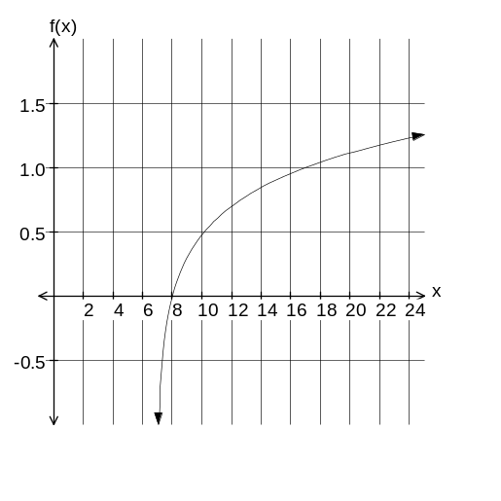 | 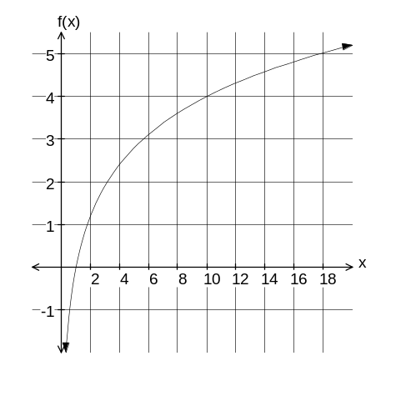

2. The function graphed in each of the following graphs is of the form y = log k x.
Examine these graphs and then determine its equation.

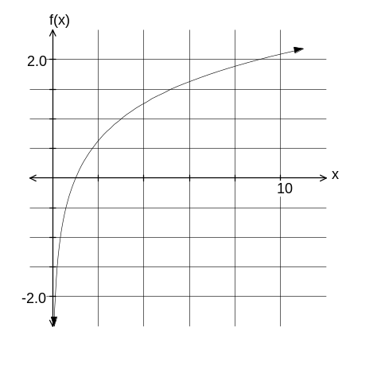 | 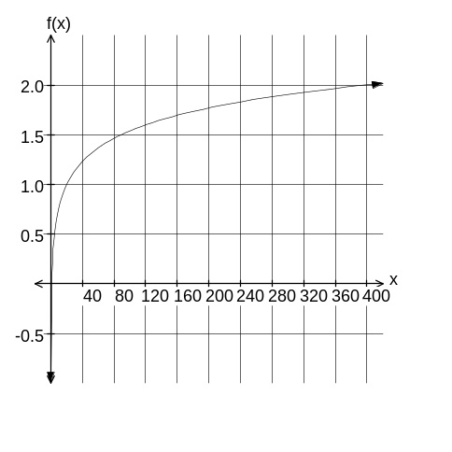
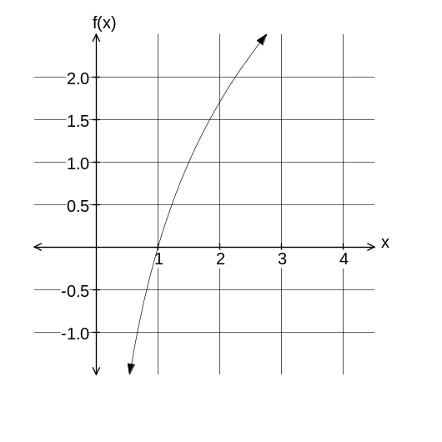 | 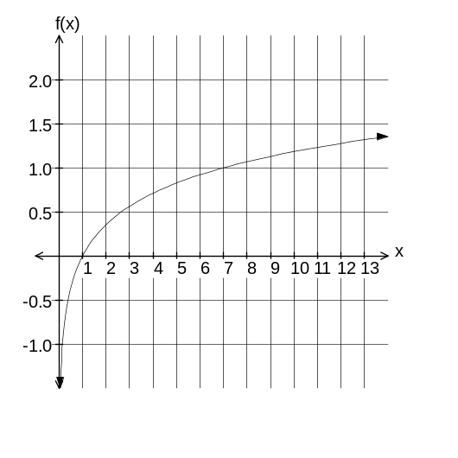

3. Determine the equation of the function graphed in each of the following, given that the graph is a transformation of the graph of y = 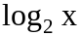.

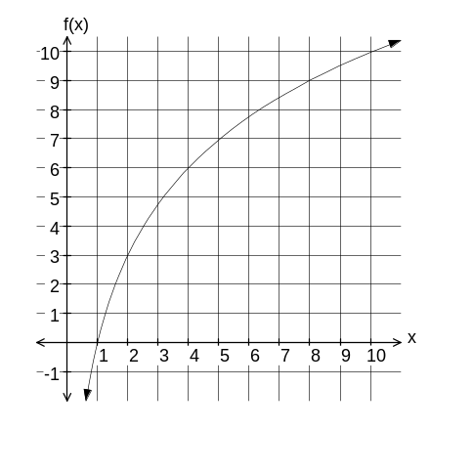 | 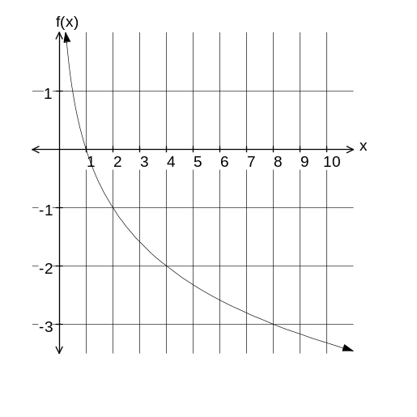
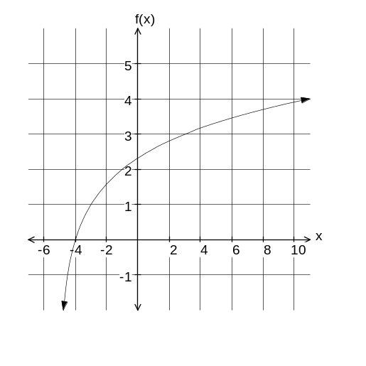 | 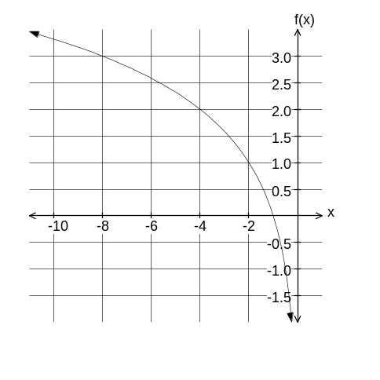

4. Each of the following graphs is a transformation of the function y = 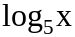.
Determine the equation of each function.

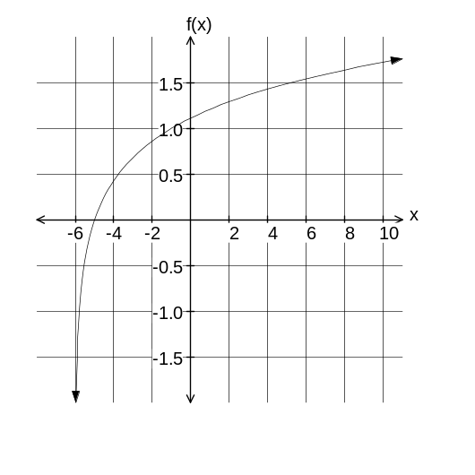 | 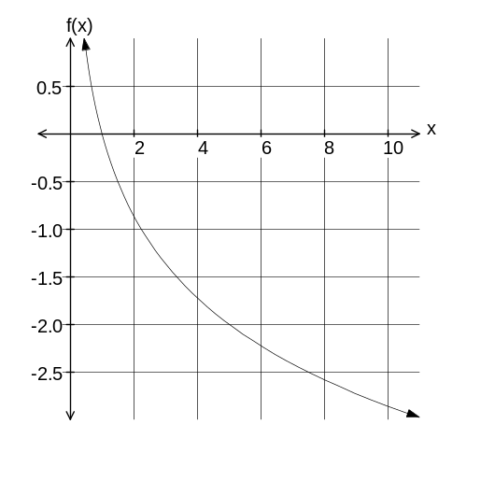
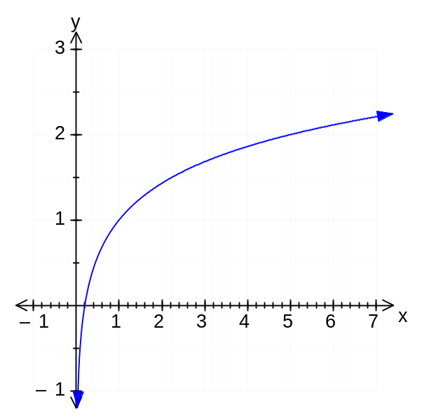 | 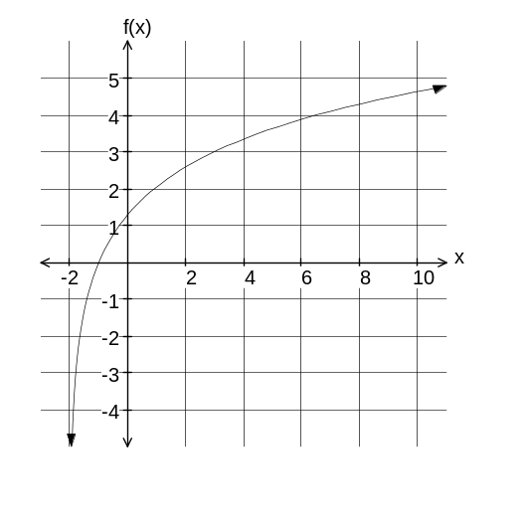

5. The following are graphs of functions of the form y = logb(x + c).
Determine the value of b and c in each case.

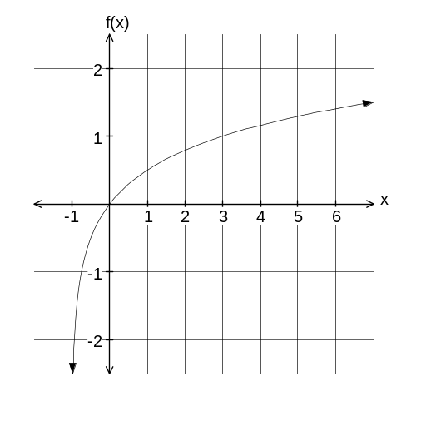 | 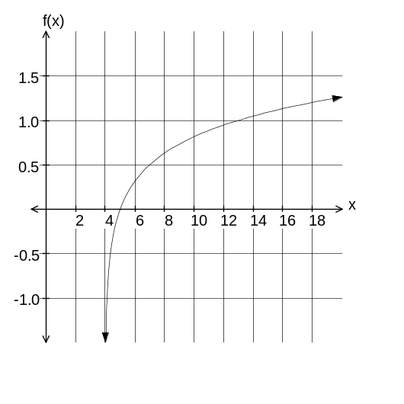
b = c = | b = c =

6. The following graph is a function of the form y = 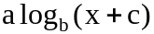.
Determine the values of a, b, and c.

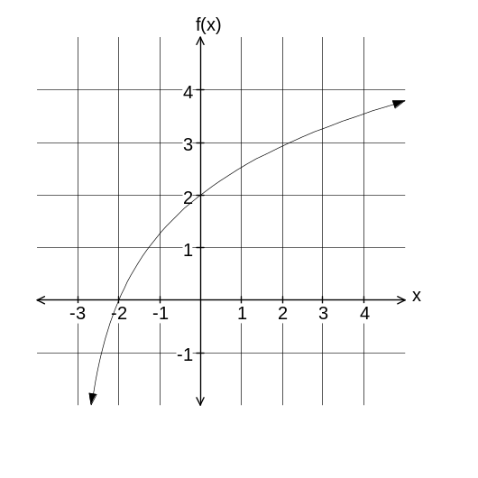
a = b = c =

